Name __________________________________ Date ___________________________ Class _____
Energy Short Answer
Directions: Answer each of the following short answer questions to the best of your ability. Be sure to answer all parts of each question. Use the grading chart to help guide your answer. The short answer part of this test is worth 20 points. Good luck!

- Examine the picture of the basketball game below. Identify at least three forms of energy that you see in the picture. Describe where you see that form of energy and how you know it’s an example of that form of energy.
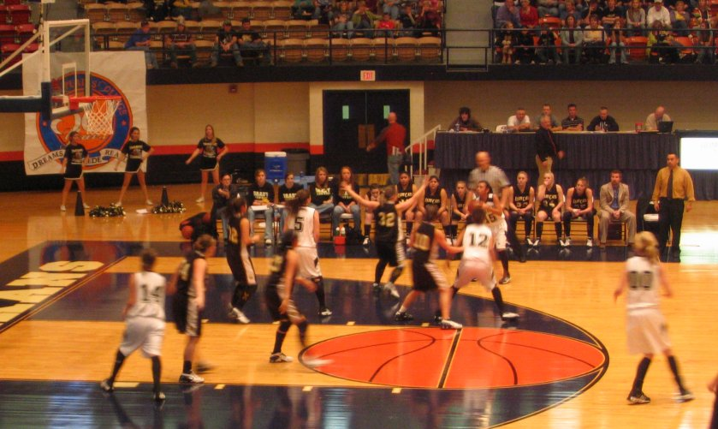

- Miss Butler wants to cook dinner for her boyfriend, but she’s not sure what to cook. Give her advice on what she can cook using each of the three methods of heat transfer we discussed in class. In your response be sure to include: a) what food (or foods) Miss Butler can cook; b) what method of heat transfer is used to cook that food; c) how that method of heat transfer is being shown.

